More Heat With Less Wood

Call for Wood Energy Projects

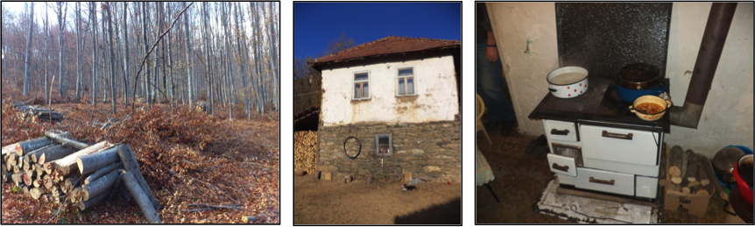
Open until 15th September 2015

How to provide healthy, affordable and resource efficient wood energy to people in South-Eastern Europe and Central Asia? Up to 90% of households in rural areas in this region use wood for heating and cooking. Socio-economic constraints and lack of knowledge on the complexity of the use of firewood often prevent users from unlocking the full potential of wood energy and minimize threats to health. The use of wood can be beneficial for the wellbeing of the people, the environment and the climate when used properly and in insulated living space. Increasing the efficiency at every stage of the supply and demand side is key to make wood a clean and effective fuel that leads to numerous benefits of the humans and the climate.

Send us your wood energy project
The UNECE/FAO Forestry invites you to present the experiences that you have gained during the implementation of a wood energy project. In working groups you will have the opportunity to talk with experts from different technical backgrounds – health, housing, heating appliances, wood energy - and define key characteristics enabling sustainable use of wood for heating and cooking in households of the UNECE region.
Your experience will be a valuable contribution for a UN publication of “Best practice wood energy projects”.
Logistical support
Participants from academia, intergovernmental and nongovernmental organizations as well as development involved in projects in heating and cooking with wood in households of the UNECE region are invited to contribute to the workshop. The UNECE/FAO Forestry and Timber Section can provide logistical support to some of the presenters, experts and interested stakeholders.
Hand in your good practice wood energy project
Please fill out the short form with information on your wood energy project. This information will be the basis for the decision of including your wood energy project into the UN publication “Best practice wood energy projects.”
Send the filled out form to woodenergy.timber@unece.org. We will inform eligible and accepted projects by mid of September. For further information please visit the website: http://www.unece.org/forests/moreheat2015.html.

The event is organized in collaboration between the Fachagentur Nachwachsende Rohstoffe, the Bern University of Applied Sciences and CARMEN e.V. with support of the Permanent Mission of Germany to the Office of the United Nations in Geneva.

Project Sheet
Please fill out and hand in this short form with information on your wood energy project by September 15th. This information will be the basis for the decision of including your wood energy project into the UN publication “Best practice wood energy projects.”
Send the filled out form to woodenergy.timber@unece.org. We will inform eligible and accepted projects by mid of September. For further information please visit the website: http://www.unece.org/forests/moreheat2015.html.
Project Title
Please indicate the project title.
Project status
Please indicate the project status and duration.
Geographical scope
Please indicate the country and geographic region of the project.
Project time frame
Please give the time frame for implementation as well as the current status of the project.
Project objective
Please describe the project objective (max. 300 words)
Target group
Please name the target group(s) and how they were involved in the different project phases.
Measures of implementation
Please name the main project activities.
Measuring the performance
How was the project performance measured? Which were indicators of progress?
Achievements
Which impact did the project achieve? Can it be quantified?
Identified challenges
Which were the major challenges of the project?
Cross sectorial aspects
Please describe whether and how the project addressed cross-sectorial aspects of wood energy for households?
Follow-up
Are future projects or follow-up activities planed.
Lessons learned
Please name a few of the lessons learned and recommendations to others.

